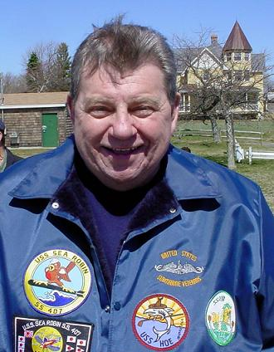

Victor Nawrocki, 24Sep39 to 1Feb09

It is with sad duty to report the passing of Victor Nawrocki, Past Commander & Holland Club member of Long Island Base. Victor passed on 1 Feb 2009 at the Stony Brook Veteran's Home. He & his wife, Nancy, reside in Middle Island, NY. He qualified on the USS Sea Robin (SS407) in 1958.

Victor will be reposed for one day at the Giove Funeral Home, 640 Middle Country Rd., Selden, NY (631-345-6700) 4 Feb 2009. Viewing hours will be from 2 pm to 4 pm and 7 pm to 9:30 pm. All hands are urged to attend the evening viewing, as there will be a USSVI memorial ceremony. Please wear your SubVet jackets, shirts, vests, hats, etc. Cdr. Sinacore would like to see as many members as possible.
“Sailor, Rest Your Oar”

