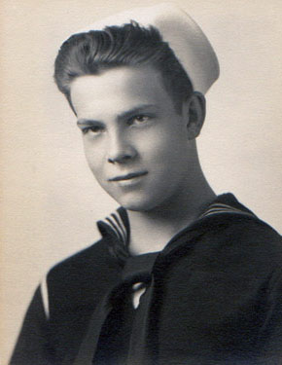
ROSELLE, Curtis C., 78, of Kirkland, Wash., died at his home on Monday, Feb. 26, 2007. Mr. Roselle was born on July 26, 1928, in Forty Fort to Robert and Clara Coughlin Roselle. He grew up in the family home on Yeager Avenue and graduated from Forty Fort High School in 1945. He joined the Navy the following year. He served initially on Adak in the Aleutians and soon thereafter volunteered for service in the submarine force. On Nov. 28, 1947, he married his hometown sweetheart, Lucille Lloyd. They lived in many areas in the United States, including Key West and Washington, D.C., but mostly in New London, Conn. While Lucille raised their family of five lively children, he prowled the North Atlantic and Barents Sea. He rose through the ranks from Seaman to Lieutenant Commander and twice received the Navy Commendation Medal. After 27 years, he retired and accepted a job with Honeywell Marine Systems Center in Seattle. While working for Honeywell, he was a guest at a black-tie affair in Washington, D.C., where he alone received the Gold Medallion from the CIA. He was a regular volunteer of the Regional Branch of the National Archives and lectured on various genealogy subjects throughout the Northwest. His wife passed away in December 2005. His daughter Cindy Prosch-Jensen died in 1999. He is survived by four children: Curtis Roselle Jr., Norwich, Conn.; Richard Roselle, Ledyard, Conn.; Douglas Roselle and Linda Roselle, Seattle area, Wash. He is also survived by a sister Priscilla Williams, Shavertown; eight grandchildren; and five great-grandchildren. A memorial service will be held on Saturday, March 10, at Flintoft’s Funeral Home, Issaquah, Wash. Interment will be in the Kirkland City Cemetery with full military honors. Friends are invited to share memories and sign the guestbook at www.flintofts.com .

Sea Robin service SOC(SS) 1954-55

“Sailor, Rest Your Oar”

