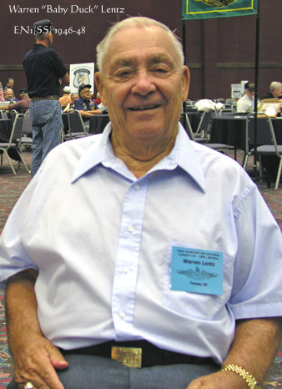

Warren A. “Baby Duck” Lentz

It is our sad duty to inform you all of the passing of a shipmate. Warren A. Lentz, 83, of Tempe, AZ, passed away on September 17, 2008. He was born in Renville, MN and moved to Tempe in 1977. Warren is survived by his loving wife of 58 years, Evelyn; his daughters, LaDonna and Laura; and his grandchildren Theresa, Kimie and Joey.
Warren qualified in submarines onboard the USS R-7 (SS-84) in 1942 and was a EN1(SS) when he left the Navy. After retiring from the Navy, he worked for The Panama Canal Company and retired from there in 1977.
Warren joined USSVI Groton base in 2000 and was a Life and Holland Club member. He was also a member of the SVWWII, American Legion, VFW, and the ELKS.
Graveside Memorial Services will be held 10:00 AM Saturday, September 27, 2008 at Valley of the Sun Cemetery, 10940 E. Chandler Heights Rd., Chandler, AZ.

“Sailor, Rest Your Oar”

