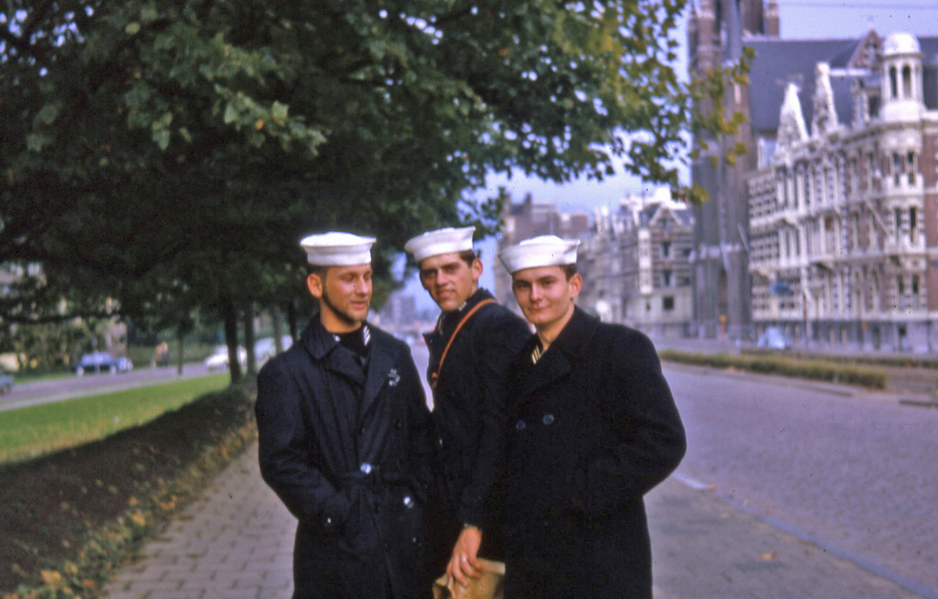
Jebing, Statz, Geigert..1964
Walter A. Geigert
Owner Buckingham Farm Supply,
Dies
DILLWYN, Nov. 4 - Walter Alien Geigert, of Dillwyn, died Friday, October 31, 2003 at UVA Hospital.
Â Â Born February 8, 1945 in Philadelphia, PA, he was preceded in death by his parents, Ewalt and Florence Geigert and his brothers, Daniel and Edward.
Â Â He is survived by his wife, Karolyn; stepchildren, Danny and Dalyn Seay and Donna Corros; grandchildren, Danlelle Seay, Jesse and Jason Echols; sisters-in-law, Muriel Geigert, Gemma Kelly and Betty Carneal; nephews, Paul, Andrew and William Geigert; nieces, Teresa Geigert and Maureen MacCarthy; great-nephews, Danny and Sean and great-niece, Tatianna.
Â Â Funeral services were held 11 a.m. Monday at First Baptist Church, Dillwyn, where he was a member. Internment, with Masonic Rites, followed in Cedar Baptist Church Cemetery.
Â Â Memorial contributions may be made to Shriner's Hospitals for Children, Mini Car Patrol, ACCA Temple, PO Box 9217, Richmond, VA 23227; Dillwyn Rescue Squad, Dillwyn Fire Department or a charity of your choice.
Â Â Dunkum Funeral Home, Dillwyn, was In charge of arrangements.
“Sailor, Rest Your Oar”

