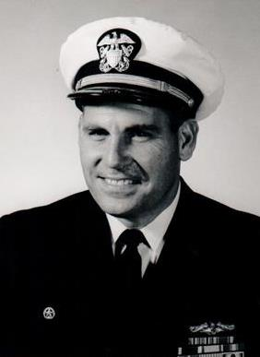

WILLIAM A. KIEHL LTjg 1952-55

Bill was born in Long Beach, CA on July 10, 1927 into a Navy family-Elmer and Nelle Kiehl. After enlisting in the Navy toward the end of WWII he followed his brother Elmer (class of 1947)into the Naval Academy (class of 1950) and then into service on submarines. Elmer left us on June 30, 2016. Among his many tours he served as a physics instructor at Penn State University. Following his command tour on the USS THREADFIN in Key West, FL he served in Washington, DC, graduated from the Naval Postgraduate School in Monterey, CA, served at USEUCOM in Stuttgart, Germany and in the Strategic Weapons Dept. at the Pentagon developing the Trident Missile program. Following retirement Bill was involved with defense contract work, civilian government, private business, and many community service projects. Bill is survived by his devoted wife of 50 years, Carol, a retired teacher: son Kevin; daughters Kimberly Aguero and Kristin Pribanic (Jim). A son, Kerry (Patti) predeceased him. He leaves eight grandchildren, a large extended family, and a multitude of friends. Visitation will be at Cunningham Turch Funeral Home, 811 Cameron St. Alexandria, VA 22314 from 2pm to 4pm, Tuesday, July 26, 2016. Interment will be at Arlington National Cemetery at a date to be announced.

