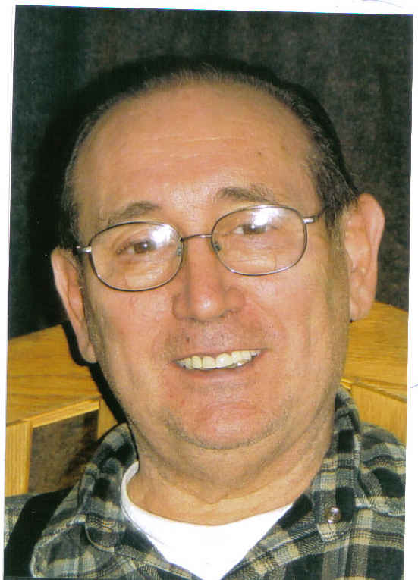

Stephen George Corsale Stephen George "Steve" Corsale, 70, passed away Sunday, August 10, 2008, at the Hospice Care Center in Louisville, Colo., after many years of living bravely with Alzheimer's disease. He was a loving husband, devoted father and grandfather, as well as a loyal family member and friend. His greatest pride was always in the accomplishments of his children and grandchildren, for whom he made many sacrifices. Steve was born on June 11, 1938, in Jersey City, New Jersey, to the late Andrew and Evelyn (nee Varano) Corsale. He lived in Garfield and Clifton, New Jersey, for much of his life. He also lived in Liberty, Mo., and most recently in Longmont, Colo. Steve worked for Ford Motor Company in both New Jersey and Missouri. He was very proud of his service in the United States Navy, from 1956 to 1966 where he served primarily on the submarines USS Sarda and USS Sea Robin. Steve was a very active member of his church and community. He served for many years as an usher, lectern and communion minister. He was also an active member of the Boy Scouts of America, American Legion and Knights of Columbus. He also had many other interests and hobbies. Steve was always ready to lend a helping hand to others in need. Steve is survived by his wife, Barbara (nee Brown) Corsale, whom he married on August 6, 1960, in Garfield, New Jersey; son, Stephen Corsale, and his wife Kathy, and their daughters, Maia and Karys, all of Longmont; daughter, Lisa Taylor and her husband Tim, and their children, Brittany, Megan, Tammy, and TJ, and three great-grandchildren, Devin, Damian and Alexia, all of Oak Grove, Mo.; and daughter, Amy Hull and husband Chad, and their son, Brady, of Fort Worth, Texas. Steve had a great passion for life which he happily shared with all he crossed paths with. He maintained his passion and involvement in life despite living with Alzheimer's. He will be sorely missed by his family and friends. Cremation arrangements have been entrusted to Howe Mortuary and Cremation Services, Longmont. Mass of Christian Burial will be held at 1 p.m. on Thursday, Aug. 14, at St. Francis of Assisi Catholic Church, Longmont. In lieu of flowers, memorial donations may be made to the Alzheimer's Association, Colorado Chapter, 455 Sherman Street, Suite 500, Denver, CO 80203 or HospiceCare of Boulder and Broomfield Counties, 2594 Trailridge Drive East, Suite A, Lafayette, CO 80026. Please share thoughts, memories and condolences with the family at www.howemortuary.com

“Sailor, Rest Your Oar”

