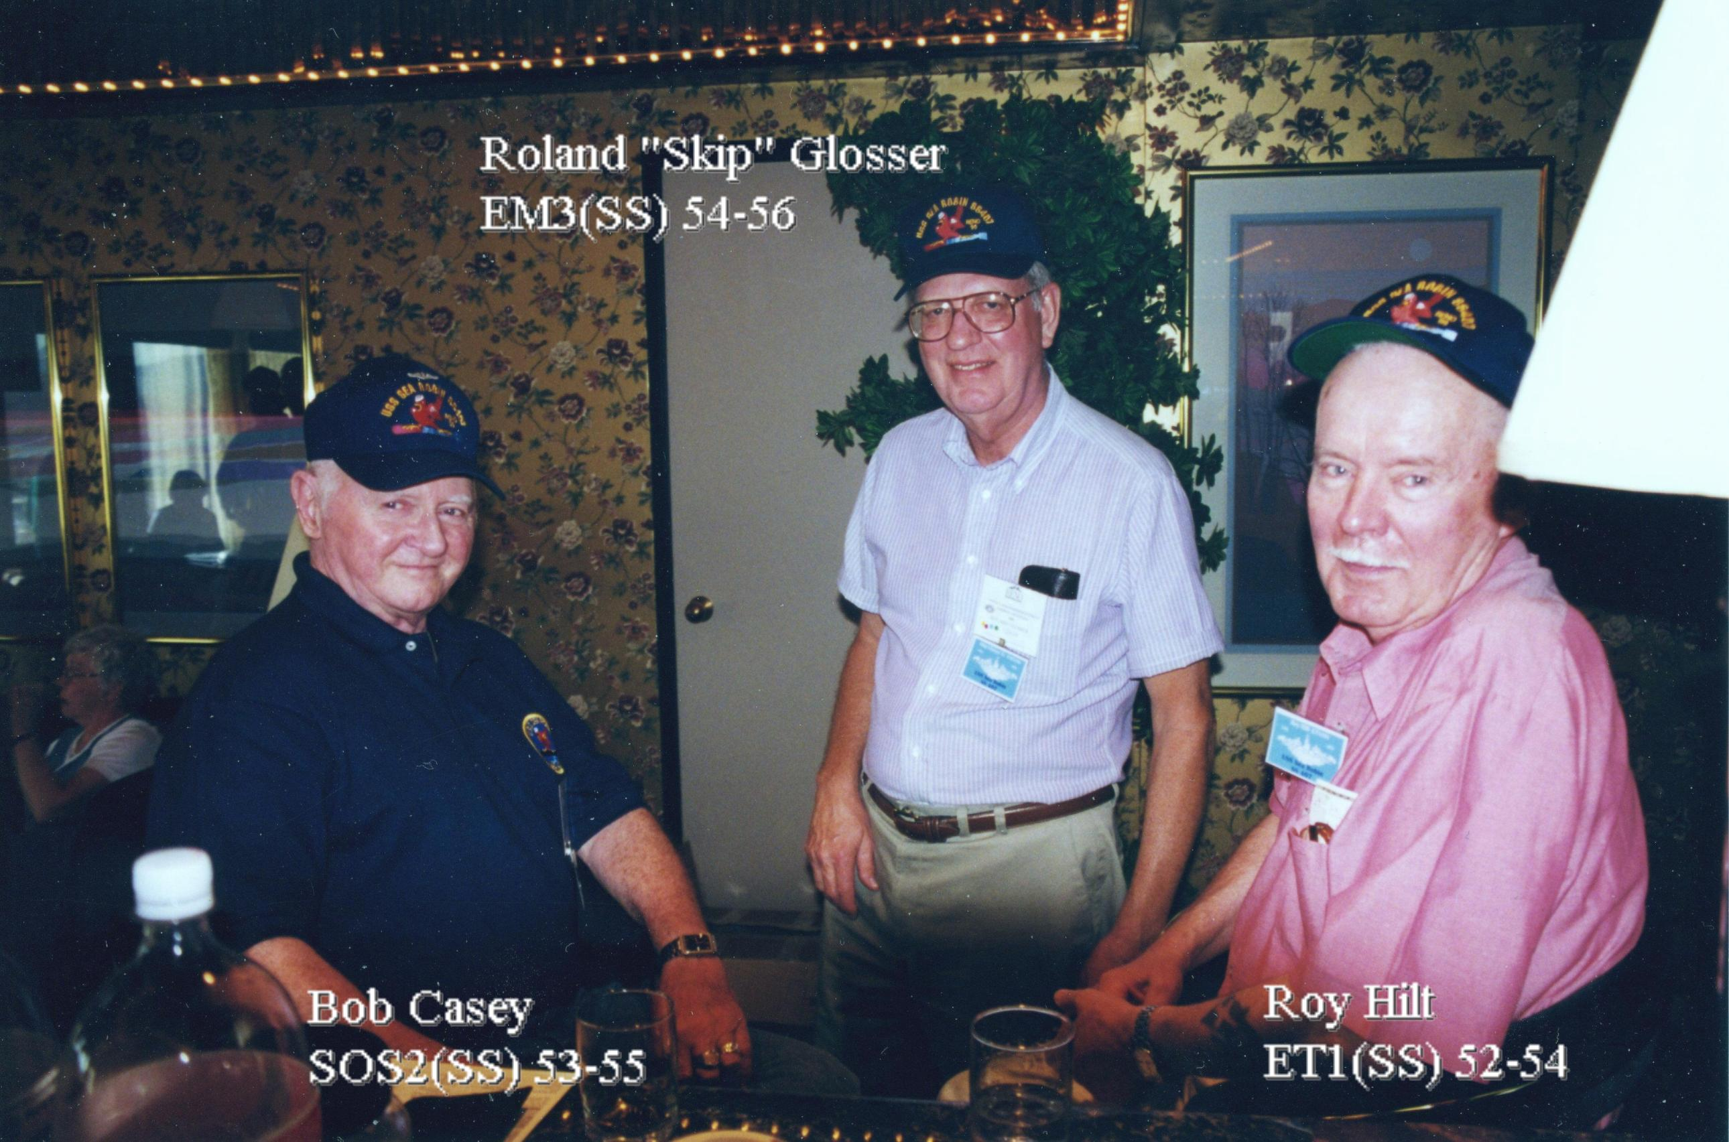

HILT, Roy August, 80, of Uncasville, passed away Friday, April 20, 2007, at Yale-New Haven Hospital following a brief illness. Mr. Hilt was born March 6, 1927, in Fort Bragg, Calif., to August Julius Hilt and Elvi Adeline (Gustafson) Hilt. A master chief electronics technician in the U.S. Navy, Mr. Hilt enlisted in 1945 and retired after 20 years of service. He was chief of the boat aboard the USS Lafayette SSBN-616 and also served aboard the USS Seawolf SSN-575 and USS Sea Robin SS-407. He received nuclear training at Union College, Schenectady, N.Y., where he met and married his wife of nearly 51 years, Marguerite Vera (Rhodes) Hilt and was eventually transferred to the U.S. Navy Nuclear Power School in New London, where he was an instructor. Mr. Hilt was employed at the Naval Underwater Systems Center as an electronics engineer and electronics technician for many years following his service in the Navy. An amateur radio enthusiast, Mr. Hilt recently celebrated 60 years as a licensed ham radio operator with the call letters K1JNR. He was a member of the Nutmeg Chapter of the Quarter Century Wireless Association Inc., the U.S. Submarine Veterans Association, and he enjoyed cooking, playing the banjo, boating, and having fun with friends. In addition to his wife, he is survived by three sons, Al Hilt of Uncasville, Kenneth A. Hilt of Westerly, and Richard A. Hilt of Niantic; and a daughter, Lisa Marie Russell of Uncasville. There are no calling hours. Services will be private for the family. The Montville Funeral Home of Church and Allen, Rte 32, Montville, is entrusted with arrangements.

“Sailor, Rest Your Oar”

