Robert H. (Bob) Holmes

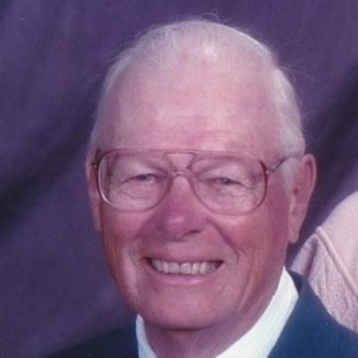
Holmes, Robert (Bob) H.
Endicott: Robert (Bob) H. Holmes, 86, of Endicott, joined the love of his life, Jean B. Holmes on Friday February 13, 2015 with family by his side. He was predeceased by his wife of 57 years, Jean; parents, Harold and Anna Mae Holmes; brother-in-law, George Avenia; and nephew, John Meredith. He is survived by a large and loving family including his sister, Betty Avenia; his five children and spouses, Sharon Phipps and her fiancé, Russell Reid, Gary and Emma Holmes, Michael and Sheila Holmes, Roger and Shirley Holmes, and Jesse and Paige Holmes; 10 grandchildren, Jeremiah Holmes, Shari and Jeramie Bell, Monica and Rick Gagne, Staci and Philip Gardner, Heather Spivey, Jessica and Mark Hathaway, Anthony and Bonnie Holmes, Jesse Holmes, Andrew Holmes, and Daniel Holmes; nine great- grandchildren, Bailey Gagne, Maddilyn Gardner, Daniel Spivey, Aubrey Gagne, Mackenzie Bell, Jacob Hathaway, Logan Holmes, Philip Gardner, Claudia Holmes; and a tenth great-grandchild due later this year. He was valedictorian of his high school class where he met and later married the love of his life. After college, he enlisted in the US. Navy. Part of an elite group, he served on submarines during the Korean War years. His training as a radar and sonar tech on the USS Sea Robin and the USS Becuna prepared him for his first career with IBM as an engineer supporting the country's early space programs. Following his father's legacy in education and wanting to support children, he left IBM in his mid-40s and returned to college, receiving his Master's Degree in Elementary Education from Cortland State University. He spent his teaching career in the Union Endicott School District as a sixth grade teacher at TJ Watson. For many of his students, he was that one teacher they will never forget. He also

influenced children through his many years as a West Corners little league baseball coach. One undefeated season he was asked how he won 22 games in a row to which he responded simply "I had good players." An avid sports enthusiast, he was a fixture at all the local sports venues. After retirement, Bob and Jean enjoyed many years of unconventional travel adventures together and wintered in Florida. He remained active throughout his life and many will know him for his long walks around the West Corners area and in later years at the mall. He played his last golf tournament with his sons in July of 2014 with stage 4 cancer, missing a hole-in-one by inches. He was an active member of local Korean War and Submarine Veterans groups for over 20 years. Bob was a quiet, humble and kind man who role modeled grace and dignity even through a very difficult illness. He will be missed by his loving family who so respected and admired him. Now on eternal patrol . . . A funeral service will be held on Wednesday, February 18, 2015 at 10:00 AM from the Central United Methodist Church, 17 Nanticoke Avenue, Endicott. Rev. Michelle Bogue-Trost, Pastor of his church will officiate. The family will receive friends at the Coleman and Daniels Funeral Home, LLC, 300 E, Main St., Endicott, Tuesday February 17, 2015 from 5 to 8 PM. The Sub Vets and Korean War Vets will offer a brief service on Tuesday at 7PM at the funeral home. Immediately following the church service burial will be in the Maine Cemetery, Maine NY. In lieu of flowers, please consider a donation to the United States Submarine Veterans, So Tier NY Base, % Patrick Ulmen, 1108 Rodman Road, Endicott, NY 13760.


