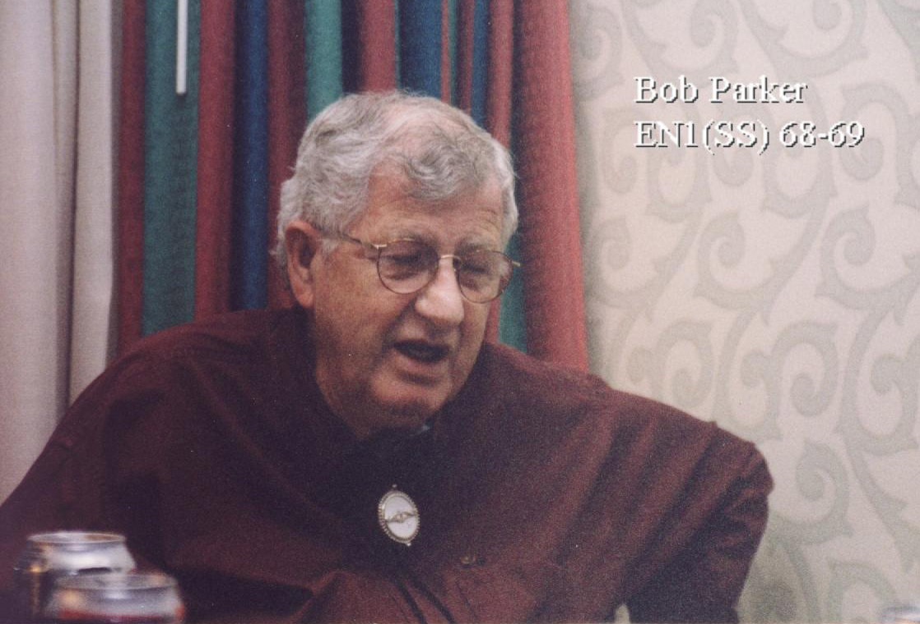

Robert A. Parker , Virginia Beach
Monday, Jan. 24, 2005
(c)The Virginian-Pilot
Robert A. Parker, born Dec. 6, 1934 in Tarboro, N.C., died Jan. 22, 2005
at Sentara Virginia Beach General Hospital with his loving wife of 45
years at his side. Bob was a proud submariner, retiring as a first class
after serving 20 years of active duty. He received the Korean, National
Defense and the China Service medals. He joined Norfolk Dredging Co.
after the Navy, where he served as an operating engineer for 23 years.
Bob is survived by his wife, Sylvia H. Parker; loving son, Robert A.
Parker and wife Ann S. Parker of Richmond; four grandchildren, Lauren,
Reid, Madison and Charlie Parker; sisters, Ruth Elliott, Irene Senter,
Mary Elizabeth Ferrell, and Ann Meeks; and brother, Joseph Parker. He
was preceded in death by his mother, Lenora Felton Parker; his father,
Harvey Milton Parker; and brother, Thomas Parker. Bob was an active
member of the Sub-Vets Association, DAV, Fleet Tug Association, Fleet
Reserve Association, International Union of Operating Engineers and
Ducks Unlimited. The family will receive family and friends at Rosewood
Kellum Funeral Home, 601 W. Witchduck Road, Virginia Beach, on Tuesday
from 6 to 8 p.m. A graveside service will be held at Rosewood Memorial
Park Wednesday at 11 a.m. In lieu of flowers, donations may be made to
the Disabled American Veterans or American Lung Association. Friends may
pay condolences at www.kellumfuneralhome.com.

“Sailor, Rest Your Oar”

