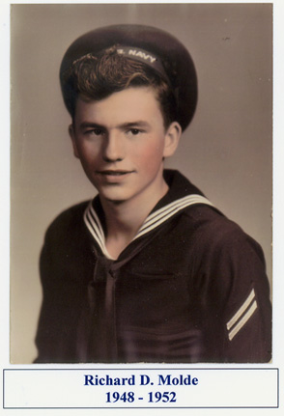
Richard Dean Molde, 78 was born in Milwaukee, Wis. on Oct. 16, 1930 to Irene and Dean Molde. He died at home on Nov. 16, 2008.
During the depression, the family moved to Blooming Prairie, Minn. until employment opportunities allowed them to move to Austin. Dick graduated from Austin High School in 1948 and he enlisted in the Navy at 17 years of age. He served on the submarine U.S.S. Sea Robin during the Korean War. When his enlistment was completed, he returned to Austin where he worked with his father as a home builder for Miller - Molde Construction Co. On Sept. 19, 1953 he was married to Berniece Wyant at St. Olaf Lutheran Church in Austin. To their union three children were born; Nancy, William and Jane. He later moved to Rochester, Minn. to begin his 25 year employment at IBM. The majority of his life was spent living in Stewartville, Minn. with his family. Dick liked to hunt and fish in his younger years, and was involved in caring for his older friends and family later on in his life. Flowers, backyard birds and animals were a source of special enjoyment for him as things became harder for him to do. Dick had a strong faith in God and always had time for devotions, religious books and programs.
He is survived by his wife, Berniece; daughters, Nancy (Tom) Allen, Kasson, Minn. and Jane (Joe) Himmer, Stewartville; sister, Diane (Dave) Dammen, Austin; seven grandchildren; three great-grandchildren; sisters and brothers-in-law; nephews, nieces and cousins.
He was preceded in death by his parents and son, Bill.
Visitation will be held at the Griffen-Gray Funeral Home in Stewartville from 5 to 8 p.m. on Thursday, Nov. 20, 2008 and one hour before the service. Dick's funeral service will be held at 11 a.m. on Friday, Nov. 21, 2008 at the River of Life assembly of God Church in Stewartville, Minn. Interment will be in Woodlawn Cemetery, also in Stewartville. Memorials are preferred to the River of Life Assembly of God Church. Blessed be his memory.

