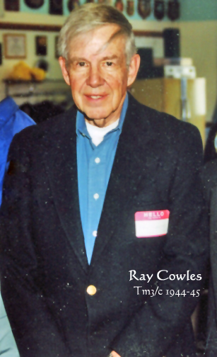

Dear Paul,

That Last Patrol is over for Ray. He died very peacefully and pain free at our wonderful Hospice. We hope he was aware that we read him the Navy Hymn.Eternal Father,Strong to Save. This happened at 7:15 on Christmas morning.

He was forever a Submariner and we all thank you for your contact with him while he was aware of it.

Fondly, Alice

Sailor, rest your oar

