RICHARD A. JOHNSTONE

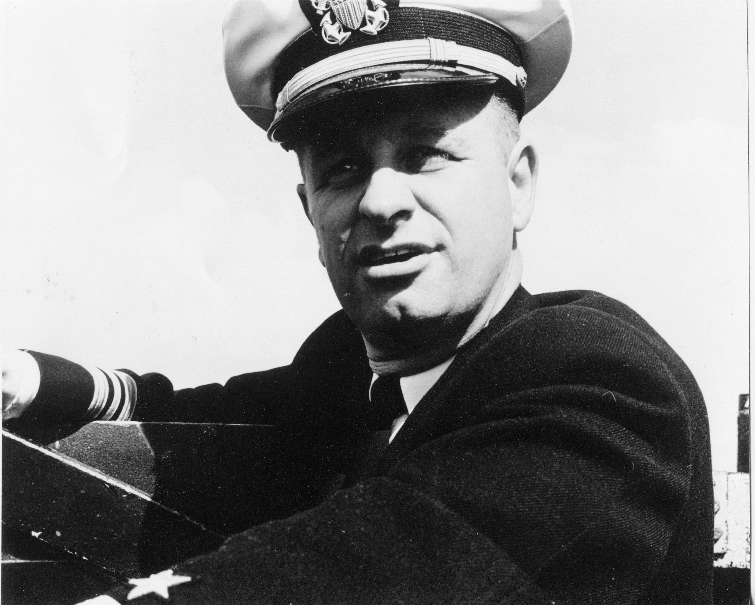
Capt. Richard A. Johnstone, U.S.N. (Ret.), 67, died Dec. 13, 1994.
He was born in Brighton, England, but lived in Waterville, N.Y., until he joined the Navy. He was a retired U.S. Navy Captain with 28 years of service in the submarine force. He was a graduate of the U.S. Naval Academy and was a volunteer at the amphibious base credit union and a member and past president of the Tidewater Retired Officers Association.
He is survived by his wife, Johanna T. Johnstone; two daughters, Brooke A. and James Asher of Charlottesville, Va., and Tracy A. Johnstone of Norfolk; one son, Richard H. and Patti Johnstone of Northport, Fla.; three granddaughters, Tara A. Johnstone of Northport, Fla., Ryan A. Asher of Charlottesville, Va., and Cydney J. Asher of Charlottesville, Va.
A memorial service will be conducted at 4 p.m. Saturday in Little Creek Naval Amphibious Base Chapel, by Capt. Robert Warren. Hollomon-Brown Funeral Home, Bayside Chapel, is handling the arrangements. The family requests that flowers be omitted and memorial donations be made to the Salvation Army or the Dolphin Scholarship Foundation at 405 Dillingham Blvd., Norfolk Naval Station, Norfolk, Va. 23511.
“Sailor, Rest Your Oar”

