It is with saddness to have to report the passing of long-time member of the Drum Base Severino (Pat) Zapatos. Pat went on "Eternal Patrol" Friday the 26th of November after long illness and hospitalization in Crestview, Florida. Pat was a member of the prestigious Holland Club and qualified on the USS Sea Robin SS407 in 1945. He served on 9 other Submarines including the commissioning crew of the Nuclear USS Sargo SSN583. He retired as a Chief Commissary Steward. Pat would have been 81 in January.
Do to illness Pat hadn't attended meeting but members in the Crestview area kept in touch with the family to keep check on him.
He will be interned at Barrancus National Cemetery on Monday 6 December 2004 with full military honors.

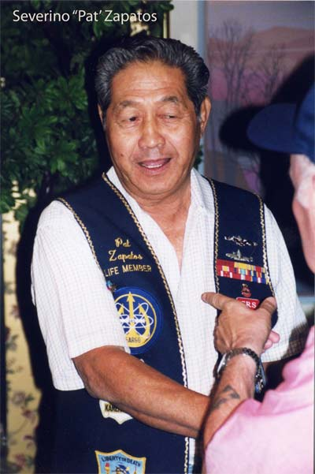

Linn McGee—News Leader Reporter
His name is Severino Zapatos but most people call him Pat. He was born on January 8, 1924 in the Philippine Islands. He doesn't look like a hero but those of my generation think he is. Pat earned his first paycheck from the Army, at age 17, when in 1940 - he helped build an airstrip for B-17s that, unknown to him at the time, were to take many years before they landed. Pat earned one peso a day for his labor. When the war broke out on December 7, 1941 Pat became a guerilla attached to the United States Army Forces in the Far East. He manned a transmitter that reached to Australia on which he made arrangements to have Thompson Sub-machine guns and carbines shipped to his group on one of the island in the Philippines. Pat actually reported to G-2, military intelligence and was captured by Japanese forces in May of 1944.
. He joined the United States Navy on July third 1946, the last Philippine National to be inducted into the Navy because they had closed the base. At that time the only job for Filipino's was to be Commissary Stewards (SD’s). Zapatos said, "I was lucky, though, because I went to submarine school”. On submarines each crewmember had to know all of the jobs on the boat. I was finally making big money, I drew $70 but that was a combination of base pay, submarine pay and sea pay."
"During my Navy career, I was on 10 submarines, the first was the "Sea Robin," and I finished riding the "Plunger" back to Bremerton, Washington for overhaul. My papers for retirement were already in and I took my retirement there in 68," Zapatos concluded. Pat said, "My wife Jennie and I were married in 1950 and she was the perfect Navy Wife, and she is still with me". "We went back to the East Coast and we both got jobs at Electric Boat Co. at Groton CT. I was material control and security in my stay there, and retired again to 1986. We went back to the Philippines for the first time since retirement had enlisted in the Navy. When we came back to the states, we found Crestview and settled here.
At first I delivered meals-on wheels and then came over here to the hospital where I work twice a week or more often if they need me.
Pat belongs to the Submarine Veterans Ala/ Flo Chapter and USSVI’s Drum Base and a member of the “Prestigious Holland Club”. “For my money, ya just can't gett'em any better than ‘Pat’ - The Editor”.. Sail In Peace Shipmate..

“Sailor, Rest Your Oar”

