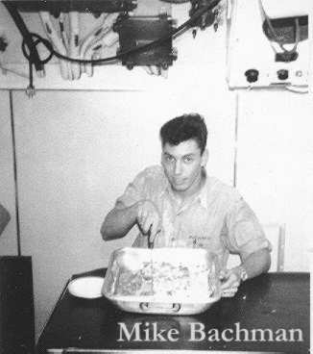

George M. Bachman "Mike"

MM3(SS) 1964-66

George M. "Mike" Bachman of Upper Pittsgrove passed away suddenly on May 19, 2009 at the age of 63. Mike was born July 17, 1945 in Wilmington, Delaware, the son of the late Guy M. and Bettie (Montague) Bachman. Mike graduated from Hamilton High School West in 1963. After graduation Mike served in the United States Navy aboard the Navy Submarine USS SEA ROBIN as MM3(SS) 1964-1966
Mike is survived by his wife of 44 years, Pat (nee Griffiths), by his children, Sandra Bachman and her husband Stephen, Sherri Shea, Shelly (Thomas) Garrison and her husband Rusty, Keith, Dennis, and sons-in-law Melvin Thomas, Shawn Shea, Sr., and Rob Hauenstein, his siblings Frank, Cheryl, and Guy, as well as his sister-in-law Sandra Otis. Mike also leaves behind 12 grandchildren: Steven, Stephanie, and Shawn Shea, Jr., Jamie Lynn Bristol, Joshua and Rebecca Thomas, Essence and Dejarae Lindsey, Caine, Camryn, Devon, and Justice Bachman, and his only great-grandchild, Aidan Michael Hauenstein.
Mike retired from PSE&G after more than thirty years of dedicated service. After his retirement Mike spent time traveling, flying, playing golf, woodworking, caring for his beloved dogs, and defeating his grandchildren at video games.
The visitation for Mr. Bachman will be held on Sunday night, May 24, 2009 from 6 till 8pm at the ADAMS FUNERAL HOME, 111 S. Main St., Elmer, NJ 08318 and again Monday afternoon, May 25th, from 1 till 2pm at the funeral home. The service will follow at 2pm with interment at Chestnut Grove Cemetery in Elmer. The family has suggested that donations be made to the , 1851 Old Cuthbert Rd., Cherry Hill, NJ 08034.

“Sailor, Rest Your Oar”

