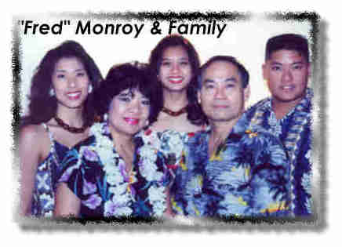
MONROY, Bonifacio Bonifacio S. Monroy, Jr., age 69, husband of Estrelita Cachola Monroy, of Ladson, passed away on Wednesday, June 06, 2007. The family of Mr. Monroy will be accepting visitors this evening at CAROLINA MEMORIAL FUNERAL HOME, 7113 Rivers Avenue, North Charleston, SC from 6:00 until 8:00 pm. Funeral service will be held at Carolina Memorial Funeral Home Chapel on Saturday, June 9, 2007 at 11:00 am. Mr. Monroy was born on May 26, 1938 in Santa Ana, Bulacan, Philippines to Mr. Bonifacio Monroy, Sr and Mrs. Flora Corazon Monroy. He was a 20 year retiree of the United States Navy as was a Chief Machinist. During his military career, he was aboard the USS Sea Robin Submarine as a Second Class Machinist Mate. He was sent to Pearl Harbor Submarine Base with the Naval Base Security as became Chief before he joined the USS John Adams, (Blue crew), a nuclear submarine. He retired from the United States Navy in 1978. His last tour was aboard the USS Orion as a leading Chief Petty Officer. He then worked at Cummins Engine as a wastewater tester for 5 years. He then worked at the Naval Shipyard (Shop #362) testing submarines after they had been overhauled. He then worked for Lockheed in the parts assembly department and then for Caterpillar in the shipping/receiving department. He was a member of the International Baptist Church in Goose Creek and a member of the Philippine Cultural Society of Charleston. He was a wonderful husband, father and grandfather. He will be greatly missed by his family and friends. Survivors include his wife of 39 years, Estrelita Cachola Monroy, two daughters, Leilani Cain of Atlanta, GA, Larena Casimiro of Las Vegas, NV; one son, Laverne Monroy of Charleston, SC; one sister, Rosario M. Reyes of Chicago, IL; four brothers, Gabriel S. Monroy of the Philippines, Cecilio S. Monroy of Charleston, SC, Salvador S. Monroy of Chicago, IL, and Roque S. Monroy of Philippines and two grandchildren Tiara Lee and David. Flowers will be accepted at the funeral home. Online condolences may be made online to www.carolinamemorial.com. Funeral arrangements are provided by CAROLINA MEMORIAL FUNERAL HOME, 7113 Rivers Avenue, North Charleston, SC.

