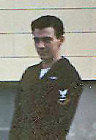

IPPOLITO-Louis, on June 19, 2006, in Vero Beach, Fla., originally of Leonardo, N.J., a longtime resident of Long Island, is survived by his loving companion of 6 years, Joyce Yarsawich; his 5 children, Louis, Jr., Lisa (DenBleyker), Michael, Lauren (Brice), and Robert; his mother, Gertrude; and his sister, Louise (Herbert). Affectionately known as "Papa Lou" to his 4 grandchildren, Timothy, Kevin, Kaitlyn, and Brianna. Service, Friday, 10:30 AM, Calverton National Cemetery. In lieu of flowers, donations may be made to the American Cancer Society.
Published in Newsday on 7/5/2006.

“Sailor, Rest Your Oar”

