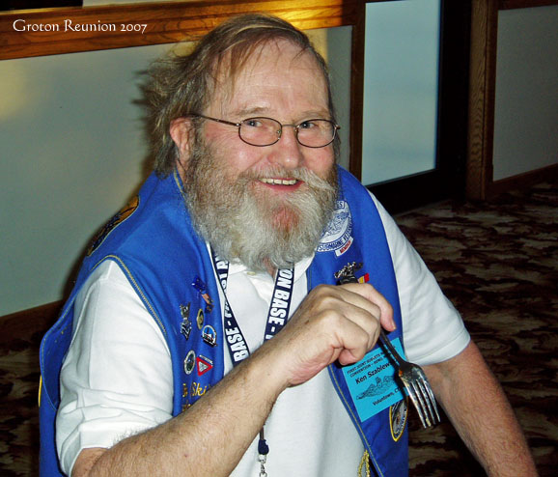

Kenneth L. Szablewski September 11, 1939 - August 2, 2008 GRISWOLD - Kenneth L. Szablewski, 68, husband of Victoria (Wawrzynowicz) Szablewski of 69 Burdick Lane, Griswold, died at his home Saturday morning. Born in Norwich on September 11, 1939, he was the son of the late Louis and Staffie (Misiaszek) Szablewski. A retired U.S. Navy Veteran of the Vietnam War, he served from 1957 through 1977 and was honorably discharged with the rank of MS-1. He also retired from General Dynamics Electric Boat as a Plumber-Pipe fitter. Ken served as Assistant District Commissioner of the Boy Scouts of America, and was also a past Scout Master in both Montville and Voluntown. He was also a Life member of the Sub Vets of Groton, the Mystic Rod & Gun Club, and the N.R.A., and was a member of the National Field Archery Assoc., and National Archery Assoc. On December 23, 1977 in Montville, he was united in marriage to Victoria (Wawrzynowicz) Szablewski who survives along with two daughters, Megan Szablewski of Ballouville and Shelly Consolini of Torrington, one son Stuart Balestracci of Pine Mountain, GA, five grandchildren, a brother Richard Szablewski of N.J., a sister Nancy Scrapchansky of Montville, and several nieces and nephews. Graveside Services with Military Honors will take place on Friday, Aug. 8, 2008 at 1 p.m. at Pachaug Cemetery, Route 138, Griswold. In lieu of flowers, donations are asked to be made in his memory to Friends of Webster B.S.A., c/o John Haskell, 100 Lake Rd., Jewett City, CT 06351. Arrangements by Labenski Funeral Home.

“Sailor, Rest Your Oar”

