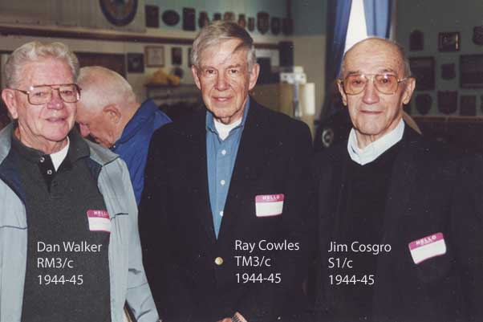

- (Worcester Telegram & Gazette)
COSGRO, James P., 88, passed away unexpectedly December 27, 2006. He is survived by his devoted wife and partner of 67 years, Bernice R. (Britton) Cosgro; his son, Donald C. Cosgro and his wife, Leslie of Millville; his daughter-in-law, Karen Cosgro of Grafton; 2 granddaughters, Christine Cosgro and Cathleen Bradford; 1 great-grandson, Colin Bradford and many nieces and nephews. He was predeceased by his son, James G. Cosgro in 2001; 2 brothers, Clarence and Paul Cosgro and 1 sister, Ruth Aubrey. Mr. Cosgro was born October 1, 1918 in Huntington (MA), the son of Clarence and Eva (Allard) Cosgro. He graduated from Westfield High School and had lived in W. Virginia, Minnesota, and then Upton before moving to Grafton in 1964. He began his working career at The Strathmore Paper Co. in Woronoco (MA). He enlisted in the US Navy during World War II serving as a submariner aboard the U.S.S. Sea Robin and U.S.S. Dace in The Asiatic Pacific Theater receiving several awards for meritorious service. After the war Mr. Cosgro became a heavy equipment and crane operator for many years working for Graves, Lundeen & Cox constructing The Massachusetts Turnpike between Grafton and Westborough. He then worked at The William Reisner Co. in Clinton before retiring in 1983. He was a parishioner of St. Marys Church in North Grafton, a member of The Nipmuc Rod & Gun Club, A.A.R.P. and Hoisters Union Local #15 AFL/CIO. He enjoyed the outdoors hunting and fishing for many years. All are invited to calling hours Tuesday, January 2nd from 6 to 8 p.m. in RONEY FUNERAL HOMES of GRAFTON, NORTH CHAPEL, 152 Worcester St. (Rt. 122 & 140) NORTH GRAFTON. A funeral Mass will be celebrated Wednesday, January 3rd at 10:30 a.m. in his Parish Church of St. Mary, 17 Waterville St. (Rt. 30) North Grafton. He will then be laid to rest in Fairview Cemetery in South Grafton.
“Sailor, Rest Your Oar”

