James Hickernell
Obituary
Guest Book
14 entries
The Guest Book is expired.
Restore the Guest Book

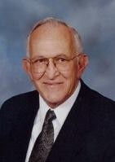
JAMES LEWIS HICKERNELL, a loving and devoted husband, father, and friend, went to be with his Lord and Savior Jesus Christ on July 8, 2014 following complications from pneumonia. He was preceded in death by his parents Cloyd and Katharine (Krouse) and his wife Joan, and a sister Dorothy. Survivors include his sons J. Lloyd Hickernell and wife Dorabeth, and Paul E. Hickernell, and grandsons Jim and wife Amanda, Eric and wife Katie, and David, and sister Mary Jean. Memorial services will be held at Bethel Church, 825 Bering Drive, Houston, Texas 77057, at 11:00 am Friday, July 11, 2014. Private family interment at Woodlawn Garden of Memories. Dr. Dwain Camp will officiate at both services. In lieu of flowers, the family requests memorial donations to Bethel Church.
- See more at: http://www.legacy.com/obituaries/houstonchronicle/obituary.aspx?pid=171668099#sthash.fYFzeaZ3.dpuf

