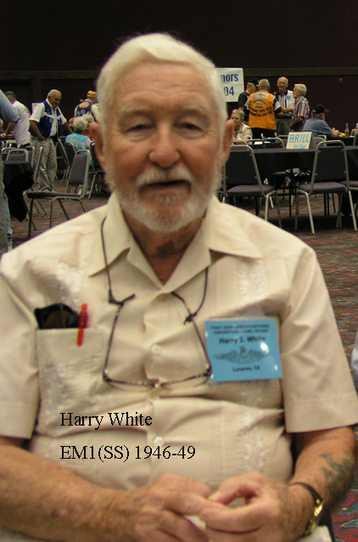

Harry James White Harry James White, of Lucerne, passed away Jan. 3, 2006. Mr. White served in the U.S. Navy.
Visitation will be held at 5 p.m. today, Jan. 5, at Queen of the Rosary Church in Lucerne, until the Vigil at 7 p.m. Mass will be on Friday, Jan. 6, at 10:30 a.m.
Arrangements by Jones Mortuary.
Published in the Lake County Record-Bee on 1/5/2006.

“Sailor, Rest Your Oar”

