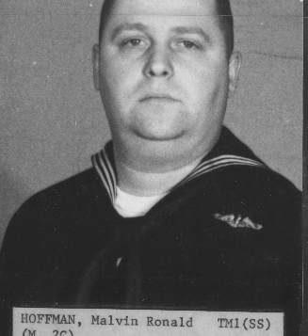
HOFFMAN, Malvin R., 80, formerly of 83 Summit St, Norwich passed peacefully on Friday, March 4, 2016. He was born on June 14, 1935 in Albany, NY the son of Charles and Ethel Hoffman. Malvin was predeceased by his wife Mary Sulis Hoffman. Malvin served on numerous submarines as a torpedoman while serving in the U.S. Navy for 20 years retiring in 1973. He was a Korean War and Viet Nam War veteran. After he retired from the Navy he worked for 22 years at the foundry at Electric Boat Company building submarines. Malvin is survived by his daughters, Cheryl Hoffman and her son Andrew of Norwich, Lisa Smith, husband Brad and daughters, Sarah and Elizabeth of Ballston Spa, NY, his step children, Donna Young, Pamela Lau, Rene, Deny, Steven and Kenneth Arsenault. A private graveside service will be held in Maplewood Cemetery, Norwich.

