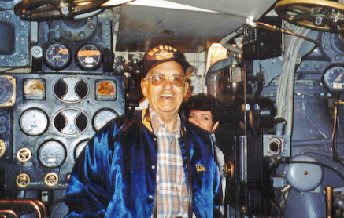

March 18, 1923 -- May 7, 2002
Richard Ober Dotts, (WWII Submarine Veteran) died at his home in Modesto on Tuesday, May 7, 2002. He was born in Wildwood, NJ on March 18, 1923 to George Dotts and Lucy (Ober) Dotts and was raised in Wildwood, NJ and Hartford, CT. Richard Dotts enlisted in the U.S. Navy in 1941. His first tour of sea duty was abord the USS Sargo (SS188). During the summer of 1941, the Sargo left Pearl Harbor for Manila Bay in the Phillipine Islands and was in Manila Bay at the breakout of World War II. Mr. Dotts made seven war patrols aboard the Sargo and subsequently served aboard the USS Rock (SS274), USS Cuttlefish (SS171), USS Sea Owl (SS405), USS Sea Robin (SS407) and USS Halfbeak (SS352). He also served as one of the crew members aboard the German submarine U-2513 in bringing the U-boat from Europe to the United States for study and experimentation. He was awarded the Navy Good Conduct Medal with five bronze stars, American Defense Service Medal, American Campaign Medal, Asiatic-Pacific Campaign Medal, European-African-Middle Eastern Theater World War II Medal, National Defense Medal and the Submarine Combat Insignia with three bronze stars. In 1963 he became an instructor and Askania Diving Training Operator. He retired from the U.S. Navy on Flag Day, June 14, 1966. He worked for General Dynamics Electric Boat Division in Groton, Connecticut until 1976 when he, his wife, and his son, Robert, moved to Modesto. He retired as an electrician in 1985. He will be remembered for his character, good nature, quick wit and sense of humor.
He is survived by his wife, Irene; sister, Marion Chesley of North Port, FL; half-sisters, Marie Briggs of Rio Grande, NJ and Mary Ellen Mooney of Wildwood Crest, NJ; half-brothers, George Dotts of Hampstead, NC and Joseph Dotts of Wilmington, DE; four children, Joan Martz of Atoka, TN, Richard Dotts of Baton Rouge, LA, Debra Christian of Puyallup, WA and Robert Dotts of Modesto; nine grandchildren and three great-grandchildren.
Following a private family memorial, he will have a U.S. Navy submarine ceremonial and burial at sea.
In lieu of flowers, donations may be made to Community Hospice, 601 McHenry Ave., Modesto, CA 95350.
“Sailor, Rest Your Oar”

