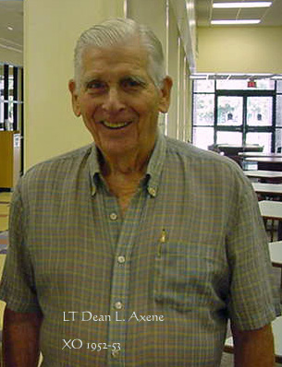

RADM Dean L. Axene, originally from Columbus, Ohio, had resided in Pensacola, FL for some years with his wife, Sally. RADM Axene qualified on and made War Patrols on USS Parche. Subsequent tours included USS Tiru, Executive Officer on USS Sea Robin (LT-XO 52-53) and USS Nautilus, and Commanding Officers on three boats; USS Croaker, USS Thresher, and USS John C. Calhoun; retiring after thirty-three years service. In addition to other organizations, he was a Life Member of both Submarine Veterans WWII, Ala/Flo Chapter, and US Submarine Veterans Inc, Thresher Base with dual membership in Drum Base.

Cards may be sent to the family care of Sally Axene, 10100 Hillview Dr., Apt 2106, Pensacola, FL 32514-5481

Sailor, Rest Your Oars.......

