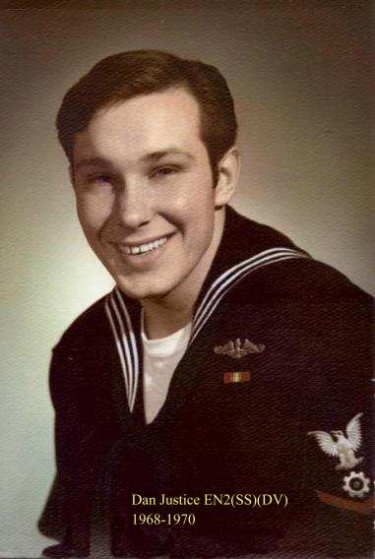
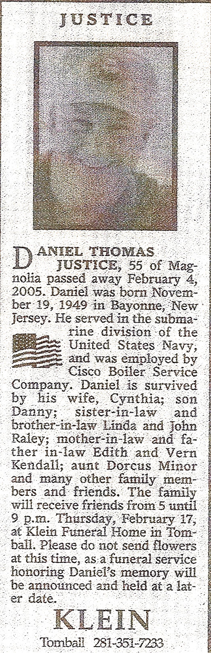

“Sailor, Rest Your Oar”

