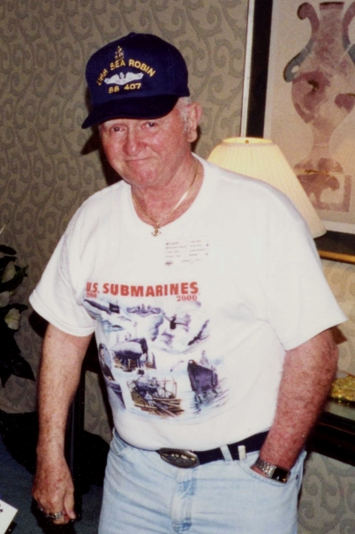
CASEY
Of Carver, January 17, Robert A., 72, husband of the late Lorraine (Tassinari) Casey. Father of Robin A. Lundgren and her late husband Ronald and Leslie M. Wibben, all of Plymouth. Brother of Walter D. Casey of Halifax and Patricia Casey of Rockland. Grandfather of Casey M. Wibben, Hollien A. Lundgren and Corey R. Lundgren, all of Plymouth. Great- grandfather of Iyanna L. Hamontree and a close friend and companion Marilyn S. Turner of Carver. His Funeral will be Friday at 8 a.m. from the Blanchard Funeral Chapel, Plymouth St. (Rte. 58 at the Rotary Circle), Whitman, followed by a Funeral Mass in Our Lady of The Lake Church, Halifax at 9 a.m. Visiting hours Thursday, 2-4 and 6-8 p.m. Burial will follow in the Mass. National Cemetery, Bourne at 11:30 a.m. Memorial contributions may be made to Cranberry Hospice/Cura VNA, 36 Cordage Park Circle/Suite 326, Plymouth, MA 02360. Visit www.blanchardfc.com for directions.

