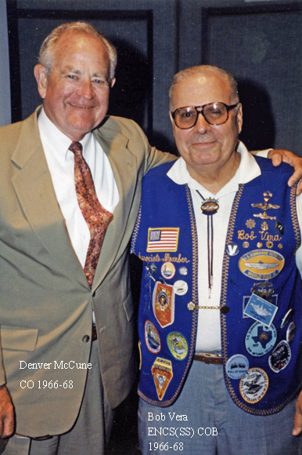
Robert Vera East Lyme - Robert J. Vera, 71, of 42 Bush Hill Drive, Niantic, died Monday at home.
He was born on Dec. 20, 1929, in New London, the son of Manny and Mary Stoddard Vera. He married Helene Marelli in 1950, in St. Joseph Church in New London. Mr. Vera was a 1947 graduate of the former Chapman Technical High School. He was a Navy veteran of the Korean and Vietnam wars, serving 20 years in the Navy submarine force. He served on several boats, including the USS Nautilus, and was chief of the boat on the USS Sea Robin. He retired in 1968. After his military career, he worked at Electric Boat in Groton for a short time, and then worked for the Navy as Supervisor of Ship Building at EB, retiring in 1987. He was a member of the Kari Hill Veterans of Foreign Wars Post in Niantic, and the Tinker Turner American Legion Post in Niantic. He was an associate member and chaplain of the Sub Vets of World War II in Groton, and the Sub Vets Inc. of Groton, and a member of the Fleet Reserve Association, Branch 237, in Niantic, where he was chaplain. In addition to his wife, he is survived by two sons, Robert J. Vera Jr. of Canterbury and Paul T. Vera of New London; two daughters, Nancy E. Vera and Cathy Vera, both of New London; a brother, David Vera of New London; three grandchildren; and a great-grandchild. A Mass of Christian Burial will be celebrated at St. Mary Star of the Sea Church in New London.
Burial with military honors will be held in Union Cemetery in Niantic.
Calling hours are 5-7 p.m. Wednesday at the Impellitteri-Malia Funeral
Home, 84 Montauk Ave., New London, with the Sub Vets of World War II holding a service at 5:15 p.m. Wednesday. Memorial donations may be made to the Easter Seal Rehabilitation Center of Southeastern Connecticut, 153 Montauk Ave., New London CT 06320, or to the American Cancer Society, 43 Bank St., New London CT 06320.
“Sailor, Rest Your Oar”

