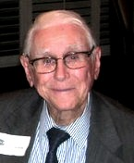

EDWARDS, William Elmo, 90, sailed on his Eternal Patrol this morning, December 29, 2016. Bill was born April 8, 1926. He enlisted in the US Naval Reserve V-6 program and reported to active duty November 29, 1943. He qualified in submarines in USS Sea Robin (SS-207) in 1945 and was aboard for War Patrols 2 & 3 (both successful). Bill also served in CSD-321 and CSD-201 Relief Crews, and USS Gato (SS-212). He was SC3(SS) when released from active duty in February 1946. Bill and his daughter Terri attended the Tarheel Base’s 2016 Pearl Harbor Memorial Dinner in early December (this month). Bill is survived by his wife, Lois. Funeral plans are incomplete.

