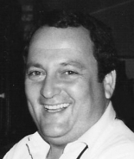

Bernard G Fazzio 
Birth:November 08, 1944 - Death:July 30, 2011
Bernard Gerard Fazzio, age 66, a U.S. Navy Veteran served on the USS Dogfish & USS Sea Robin, passed away on Saturday, July 30, 2011 in New Orleans, LA. Survivors include a son, Joe Fazzio, a sister, Joann Fazzio Mueller, a brother Frank Fazzio, nieces and nephews, Mark, Michael, Missy, Mindy, Leslie, Mimi, and Joseph. His beloved Ruby. Preceded in death by his parents, Grace Kearns Fazzio and Joseph B. Fazzio.

