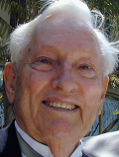
Anthony Everist Verzwyvelt , 83 OCEANSIDE -- Anthony Everist Verzwyvelt, 83, passed away Saturday, February 28, 2009. He was a Master chief ENC in the Navy for 23 years. He was highly decorated. He is survived by his wife, Theresa; daughters, Heidi and Darcy; son, Scott; seven grandchildren; eight great-grand-children.

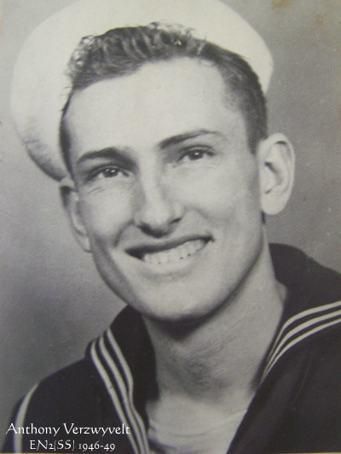

USS Archer-Fish SS-311 (1943-45) MoMM3/c
USS Sea Robin SS-407 (1946-49) MoMM2/c -EN2(SS)
USS Torsk SS-423 ( 1954-58) EN1(SS)

“Sailor, Rest Your Oar”

